Mars observations, Summer 2003

U.Denver’s Meyer-Womble Mt.Evans Observatory
www.du.edu/~rstencel/MtEvans
Telescope/camera details: 0.72m, R-C, Ap8, unsharp mask image processing.
f/84, red filter, except when noted, south up, east to left:

Long 0-90: Sinus Meridiani to Solis Lacus:
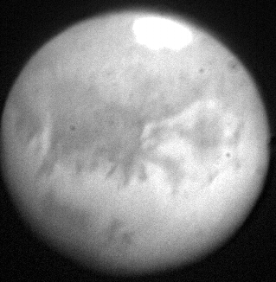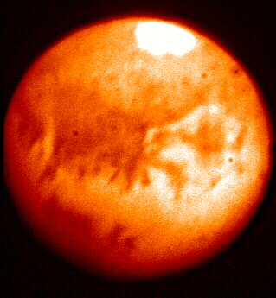
8/29/03, 0100MDT, long.20 8/29/03, 0110MDT, long.18
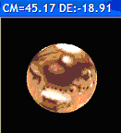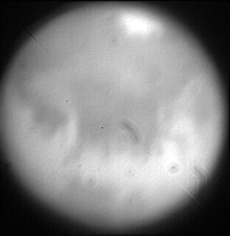
8/28/03, 2255MDT, long 24

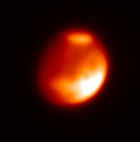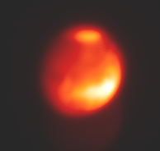
6/18/03, 0300MDT, long 45 6/20/03, 0300MDT, long 10
f/42, orange filter (Wratten 21)

Mars observations, Summer 2003

U.Denver’s Meyer-Womble Mt.Evans Observatory
www.du.edu/~rstencel/MtEvans
Telescope/camera details: 0.72m, R-C, Ap8, unsharp mask image processing.
f/84, red filter, except when noted, south up, east to left:
Long 90-180: Solis Lacus & volcanoes to Amazonis
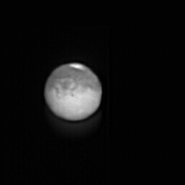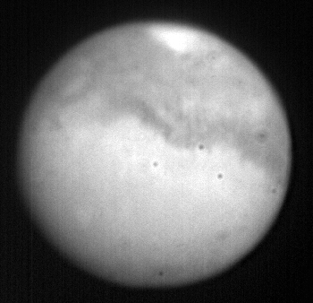
8/21/03, 23:46MDT, long 107 8/19/03 long 130
(f/21, Bessel R)
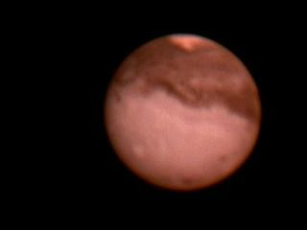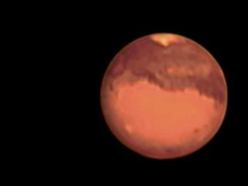
8/20/03, 02:20MDT, long 162 8/21/03, 0306MDT, long 162

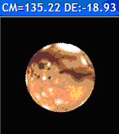
Mars observations, Summer 2003

U.Denver’s Meyer-Womble Mt.Evans Observatory
www.du.edu/~rstencel/MtEvans
Telescope/camera details: 0.72m, R-C, Ap8, unsharp mask image processing.
f/84, red filter, except when noted, south up, east to left:
Long 180-270: Amazonis to Tyrrhenum:
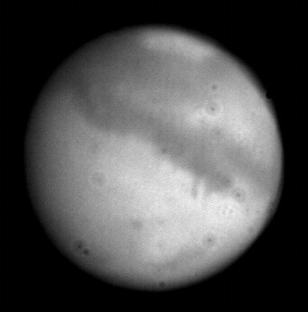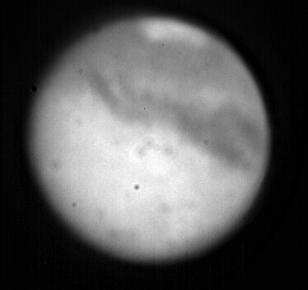
8/14/03 long~200 8/13/03 long~230deg

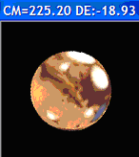

Mars observations, Summer 2003

U.Denver’s Meyer-Womble Mt.Evans Observatory
www.du.edu/~rstencel/MtEvans
Telescope/camera details: 0.72m, R-C, Ap8, unsharp mask image processing.
f/84, red filter, except when noted, south up, east to left:
Long 270-360: Tyrrhenum, Syrtis Major to Sinus Meridiani
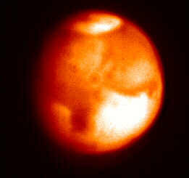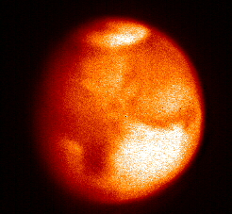
6/29/03, 0900GMT, long. 300 deg. Same after unsharp masking
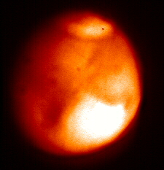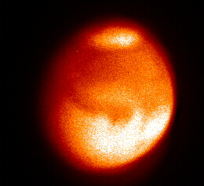
6/28/03, 0800GMT, long. 293 deg. 6/26/03, 0900 GMT, long. 332 deg.

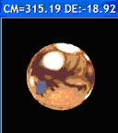 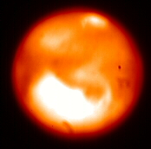 9/6/03, 05:35GMT

Mars observations, Summer 2003

U.Denver’s Meyer-Womble Mt.Evans Observatory
www.du.edu/~rstencel/MtEvans
Telescope/camera details: 0.72m, R-C, Ap8, unsharp mask image processing.
f/84, red filter, except when noted, south up, east to left:

OTHER
f/42, orange filter (Wratten 21)
6/18/03, 0900GMT, 45 deg. 6/20/03, 0900GMT, 10 deg.

f/21 unfiltered:
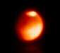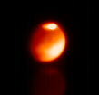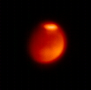
6/12/03, 0900GMT 6/15/03 0900GMT 6/18/03 0900GMT
Long. 95deg Longitude 75 deg Long. 45 deg.

For reference [source NASA]: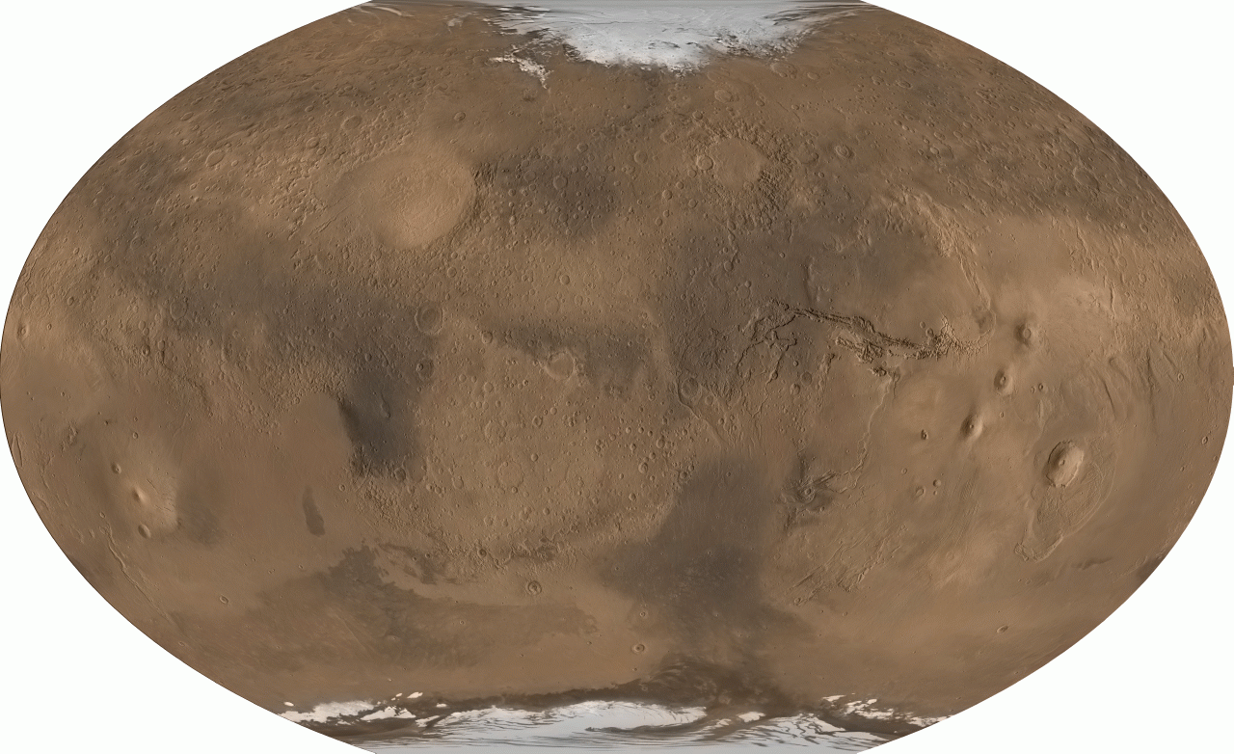
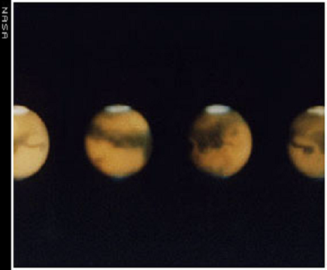
Long. 315 225 150 60
Aka Central meridian

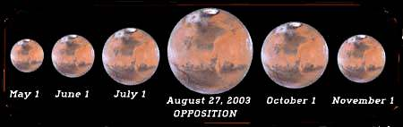
From Don Parker:
Hi Again, Tom,
First, many thanks for the info on polar alignment. Cool idea!
Second, yes, the dust storms can cover the whole planet -- for months! See the attached image called "Fig. 10." This storm hopefully won't go global, but it is starting about where the 2001 one did. I have attached a shot I took this morning between lightning strikes (I'm not kidding!).
If you are going to be doing video I would suggest using a red (Wratten-25), orange (W-22), or yellow (W-15) filter. This works even with color videos and people thing the color is cool. Mainly, this brings out surface detail by improving contrast. Also, since red wavelengths are refracted less than shorter ones, a red filter will improve image steadiness. Dust clouds show up beautifully in red light.
Even though Mars is mapped, the surface details often change, especially with dust around. This year there has been a major change in a feature called Solis Lacus. For research I mainly do polar cap regressions and cloud studies. For clouds, except dust, you need blue (W-47) filters, since Mars' atmosphere is opaque to blue and UV light. The Mars Global Surveyor is in a polar orbit and shoots along a 2:00 PM strip (Mars time), so meteorology elsewhere is missed. Jeff Beish and I have wasted the past 30 years doing filar micrometer measurements of polar cap regressions and cataloging cloud frequencies.(>25,000 clouds) This is much like root canal work. Anyway we have demonstrated that Mars is also experiencing global warming. The MGS has verified this during the past 3 apparitions. We have an article in the July S&T about Mars dust storms, and Bill Sheehan's sidebar mentions this. Bill wanted to do a whole article on global warming, but they thought it was too politically incorrect.
When you are using the 28 inch, do some visual obs. Get a Wratten-47 filter and a -25 or 29 and check out how Mars looks. The violet filter is hard getting used to, but it's like scotch -- once you get the hang of it, it's really good! You will begin to see the white S. polar cap, a bright rim along the limb, caused by morning fogs, and perhaps some white dots here and there. These are water-ice crystal clouds. Let me know when you are observing, and I can tell you what you should be looking for, unless our weather here remains horrible.
Well, enough of this babble,
Best,
Don
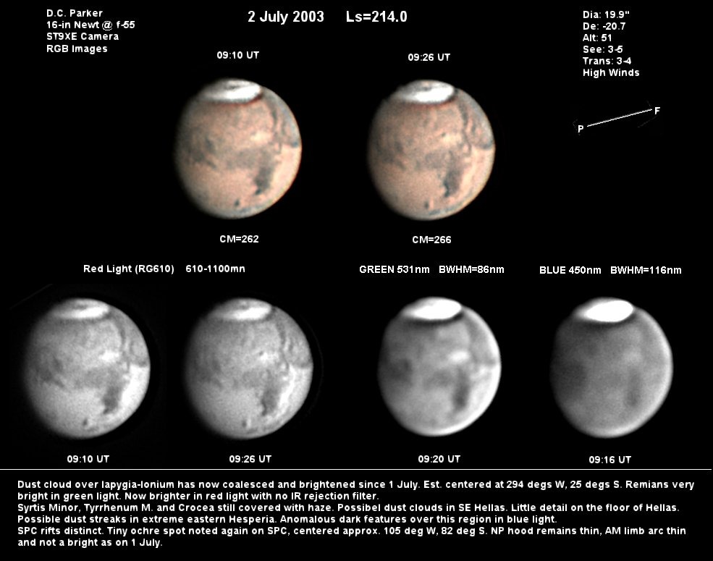

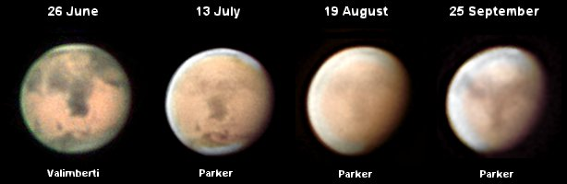
At 12:16 PM 7/2/2003 -0600, Tom Bisque wrote:
>Keep in mind that I am not a planetary guy!! :)
>
>Are you saying that the storms can get bad enough that you don't see any
>surface detail?? Aren't movies of the storms of value? And I guess, seen
>it once you have seen it all. Since the planet is mapped extremely well
>already what exactly do YOU look for (detail, wavelength, etc.)?
>
>Guess that any pointers you can give me will help. Is there anything
>special I can do way up high with the 28 inch on mars??
>
>
>-----Original Message-----
>From: Donald Parker [park3232@bellsouth.net]
>Sent: Wednesday, July 02, 2003 12:03 PM
>To: thomas@bisque.com
>Subject: Stuff
>
>
>Hi Tom,
> Thanks for the e-mail. Mt. Evans has a neat site -- will be
watching
>or
>you! Better hurry, though, since we detected a dust storm on Mars
>yesterday. Same place where the 2001 one started. Hope it doesn't grow like
>that one did!
> I'll call Dan Joyce again tonight and push him about Lucas. Also,
a
>while
>ago you mentioned something about a neat level for the ME. Is that on the
>pier? If not, could you send me one in your "spare time?"
> All for now,
> Don



