FSEM 1110: Travels in America
Sturm Hall, Room 491 Mondays & Wednesdays, 2:00-3:50 p.m.

Instructor: Ethel Swartley

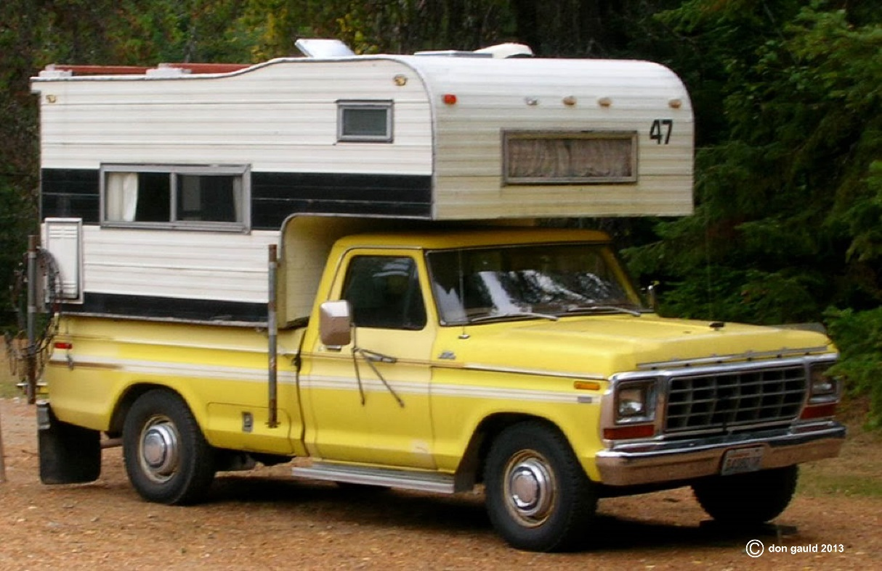
(Image used by permission from http://bicyclelog.blogspot.com/2013/11/buddy-heater-for-camper.html (Links to an external site.)Links to an external site.)

Course Topic Description
Before coming to the U.S. as an international student, you may have had many ideas of what “America” and “Americans” would be like. Arriving here, you may be surprised at what you find, or perhaps you feel your experience is limited by the microcosm of the university campus: you are here in one place, at one time, surrounded by individuals like yourself: young adults defining “life on your own”, often for the first time. Is this “American life”? Where is the “real USA”? John Steinbeck’s Travels with Charley will allow you to be an “armchair traveler” exploring the United States more broadly through the eyes of an older man writing about travels across America during the 1950s and ‘60s, a time period that still influences modern American life. Using this text as a starting point, you will be encouraged to think critically about Steinbeck’s America and to compare it with current portrayals of “American life” in the news and the experiences of others. Course activities will include critical reading discussions both in class and online and a survey project involving interviews with American peers or community members. Survey results will be analyzed and used, along with other published and online resources, to develop a U.S. culture-learning travel proposal. The content of travel and culture will be supplemented with activities to support you as you continue to develop your language and communication skills in English.

What is a First-Year Seminar?
First-Year Seminars are designed to provide students with an in-depth academic experience that will be rigorous and engaging. Students will develop the kinds of academic skills that will prepare them for successful college work, including writing, critical reading and thinking, discussion, argument and debate. FSEM faculty members have selected course topics about which they have particular expertise and enthusiasm. For students to be able to engage with faculty in the exploration of these topics is an extraordinary opportunity for academic and personal growth. Instructors of the First-Year Seminars will also serve as students’ academic advisers and faculty mentors for the entire first year. Students meet individually with their mentor during each quarter for advising and registration help. In addition, faculty mentors are a good source of support for students if they need assistance any time during their first year. The seminars will meet for 4 hours per week.

Textbook Information
You will need the following for every class session and for homework:
Steinbeck, John. Travels with Charley in Search of America (Penguin, ISBN 9780140053203)
Daily access to DU online resources, including Canvas, and University Libraries databases

Grading, Evaluation and Major Assignment Information
Students will be assessed through their preparedness for and participation in in-class activities (25%); the thoughtfulness and clarity of online reflective discussions (20%); completion of an interview project (15%); presentation of a culture-learning travel plan (20%) and accompanying written proposal (20%). Online reflections will be reviewed at the end of the course so that students can demonstrate an improvement in language, critical thinking, and depth of online interaction.
- Participation: Students are expected to be present and prepared for class by having completed assigned readings, sharing opinions and asking questions. Students are also expected to be focused and engaged during every class session without being distracted by electronic devices. Students should be flexible and willing to play various roles in class activities, as requested. Students must be respectful toward both classmates and the instructor.
- Reflective Online Discussions: Students will be asked to participate in online reflective discussions about the topics discussed in class. Successful participation will involve clearly organized and executed original postings of 250 words or more and thoughtful, significant responses to at least two classmates’ postings. Feedback on the content and language of reflective discussions will be provided weekly, and the full range of discussion postings will be evaluated at the end of the course based on improvement in language, critical thinking, and depth of interaction.
- Interview Project: Each student will initiate and complete interviews with two or more Americans using the following question: “What travel advice would you give to an international student who wanted to see the ‘real America’ and how Americans live?” Students will work with 2-3 classmates to decide who to interview, brainstorm follow-up questions prior to interviewing, and collate and analyze interview results.
- Culture-Learning Travel Plan Presentation and Paper: Students will select advice gathered during their interview projects and, working in pairs, prepare a travel plan for learning more about U.S. culture and American life. Based on the advice selected, students will use library and online resources to find information about actual costs, locations, transportation options, and activities. Travel plans, with explanations and justification of choices, will be presented orally with visual aids during the scheduled final examination period, and a written explanation of the plan must be submitted no later than one day after the final class session. Presentations will be evaluated based on content, including logical explanation of travel choices and application of interview project results (40%); clear and academic use of language (40%); professional demeanor and use of visual aids (20%). Final paper will be evaluated based on content as in presentation above (40%), logical organization (10%); use of references and citations (MLA or APA) (15%); academic style (including vocabulary) and document formatting (10%); and grammar and mechanics (25%).

Attendance Policy
Courses at the university level are centered on class discussions. This requires not only being physically present at every class, but also being prepared and intellectually engaged during class activities. For these reasons, class attendance is mandatory. You will be graded on attendance and participation. You will be allowed to make-up in-class work only at the instructor’s discretion. In order to ask about making up in-class work, you must e-mail the instructor before your absence.

Academic Honesty and the DU Honor Code
The University of Denver’s Honor Code states that:
All members of the University of Denver are expected to uphold the values of Integrity, Respect, and Responsibility. These values embody the standards of conduct for students, staff, faculty, and administrators as members of the University community. These values are defined as:
Integrity: acting in an honest and ethical manner;
Respect: honoring differences in people, ideas, and opinions;
Responsibility: accepting ownership for one’s own conduct.
As students at the University of Denver, you are asked to take the Pioneer Pledge:
Pioneer Pledge.
As a University of Denver Pioneer I pledge…
• to act with INTEGRITY and pursue academic excellence;
• to RESPECT differences in people, ideas, and opinions and;
• to accept my RESPONSIBILITY as a local and global citizen;
Because I take pride in the University of Denver I will uphold the Honor Code and encourage others to follow my example.

Cheating and plagiarism will not be tolerated in this course. Students who cheat or plagiarize run the risk of failing the course and being suspended from the University of Denver. Cheating is defined as requesting, receiving, or providing unauthorized assistance on any assignment. Plagiarism is defined as submitting the work of another as your own without proper citation. Plagiarism can be intentional or unintentional. The following guidelines should help you avoid plagiarism:
- Lifting text verbatim without quoting the author is plagiarism, whether the source text comes from a website or a published book or article.
- Using photos, charts, graphs or other images from printed or online sources without proper citation is plagiarism. This is true for both written papers and presentations.
- Using an author’s words with slight alterations is plagiarism. You must paraphrase the author’s idea in your own words and then give the author credit through a citation.
- Some students turn in papers that amount to a series of quotes. This is not plagiarism, but it is not good writing. Quotes can be sprinkled throughout a paper to add emphasis, but numerous quotes detract from a paper’s cohesiveness, leaving one to wonder if the student can write him/herself.
For more information on DU’s Academic Honesty Policy and Honor Code, see http://www.du.edu/studentlife/studentconduct/index.html

Tutoring and Other Positive Forms of Assistance
Free tutoring is available through two offices at the Anderson Academic Commons (AAC), and I encourage you to use both of them to prepare for assignments in this class:
University Writing Center
DU’s Writing Center is located in AAC Room 280. You can bring your written work to the Writing Center for a 45- minute, one-on-one consultation with knowledgeable writing consultants. I highly encourage you to take advantage of this resource; talking with others about your writing will help you create better papers, and, in the process, help you become a better writer. Trained University Writing Center staff members are available to consult with you one-on-one at any stage of a writing project.
To Schedule an Appointment at the Writing Center:
1) Go to http://myweb.du.edu and login
2) Select the "Student & Financial Aid" tab
3) Click on the "Writing Center" menu
Or: Call 303.871.7456
Center for World Languages & Culture
Next to the Writing Center, the Center for World Languages and Culture (CWLC) offers peer tutoring and English practice especially for international students. Peer tutors can help you practice for presentations and prepare for oral class discussions. They can also help you with reading vocabulary and understanding what you read. English tutors are available for drop-in tutoring during these times:
Mondays 12:30-5:30 p.m.
Tuesdays 2:00-6:00 p.m.
Wednesdays 9:00 a.m.-12:00 noon
Thursdays 10:00 a.m.-12:00 noon, 1:00-5:00 p.m.
Fridays 10:00 a.m.-12:00 noon
For Students with Disabilities: ADA Statement
DU complies with the Americans with Disabilities Act of 1990. If you have a documented disability, please contact the Disabilities Service Program (DSP) at
(http://www.du.edu/studentlife/disability/dsp/accommodations.html). Together with this office, we will be able to work out reasonable accommodations to assist you as needed in this course.

Tentative Course Outline
*NOTE: This schedule is subject to change. The most up-to-date schedule will always be found on the Assignments and Syllabus page as course assignments are added and updated.
Week 1 (January 6):
Introductions and Course Expectations
Who was John Steinbeck, and why did he travel?
Week 2 (January 11-13): Long Island Hurricane
Roles in a group discussions
Participation in online discussions – student example postings
Reflective Discussion #1
Week 3 (January 18-20): New England
Plastic Motels and Brimstone Preachers
Monday: No Class – Martin Luther King Jr. Holiday
Week 4 (January 25-27): Upstate New York and Chicago
Crossing Borders & Lonely Businessmen
Reflective Discussion #2
Week 5 (February 1-3): The Upper Midwest
Park bureaucracies, Continental Divide disappointment
Introduce Interview Project - plan questions, choose subjects, discuss approaches
Week 6 (February 8-10): California & Texas
Describing Home, Sense of Place
Conduct interviews
Reflective Discussion #3
Week 7 (February 15-17): New Orleans
Race and Desegregation
Collate and interpret interview results
Begin researching travel options
Week 8 (February 22-24): The End of the Trip
Field Trip: 60th Annual Colorado RV, Sports, Boat & Travel Show (Exact Date TBA)
Reflective Discussion #4
Week 9 (February 29-March 2):
Research & draft travel proposals
Documenting to avoid plagiarism
Week 10 (March 7-10):
Monday: Travel plan draft reviews
Wednesday, March 9: Travel plan presentations
Thursday, March 10, 2:00-2:50 p.m. - Final Examination (Written travel plans due)

