Self Sufficient Login Instructions
Your assigned staff sets up your Zoom class. Most facilitators prefer to arrive 15-30 minutes early to test equipment and practice. The class is also set to run 30 minutes past the end of class to allow for ongoing discussion.
Your assigned staff will help with the following:
- Set up a practice with you before the first class – test audio/video, share screen, etc.
- Recruit CA’s - Class Assistant(s), to Admit registered participants and help you manage Q&A and discussion.
- Set up class start and end times per your preferences.
- Email you final class roster the Friday before class begins.
- Email Zoom registration to participants the weekend before first class.
- Send weekly reminders to registered participants.
- Set up Polls, if needed.
- Resolve technical issues before, during or after class.
- Check in on your class and be available during class time for urgent issues.

Before you login to Zoom at DU
SIGN OUT FROM YOUR PERSONAL ZOOM ACCOUNT AND CLOSE YOUR WEB BROWSER.
You may need to restart your computer or use a different web browser than you use with your personal account. Use this link TO LOGIN TO THE du Zoom account: https://udenver.zoom.us/
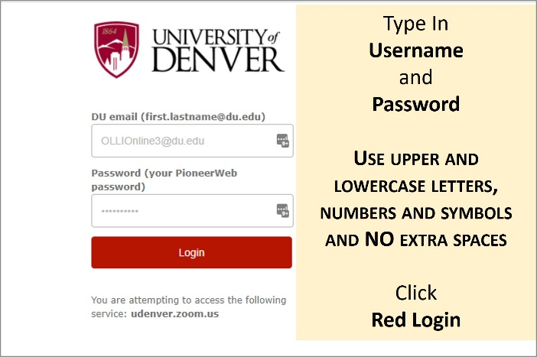
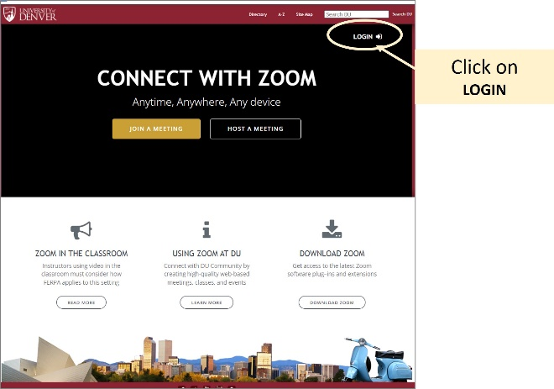
Arrive at LOGIN screen. Click LOGIN and type Username & Password provided to you.

If you arrive on Profile Page, click on Meetings on left side.
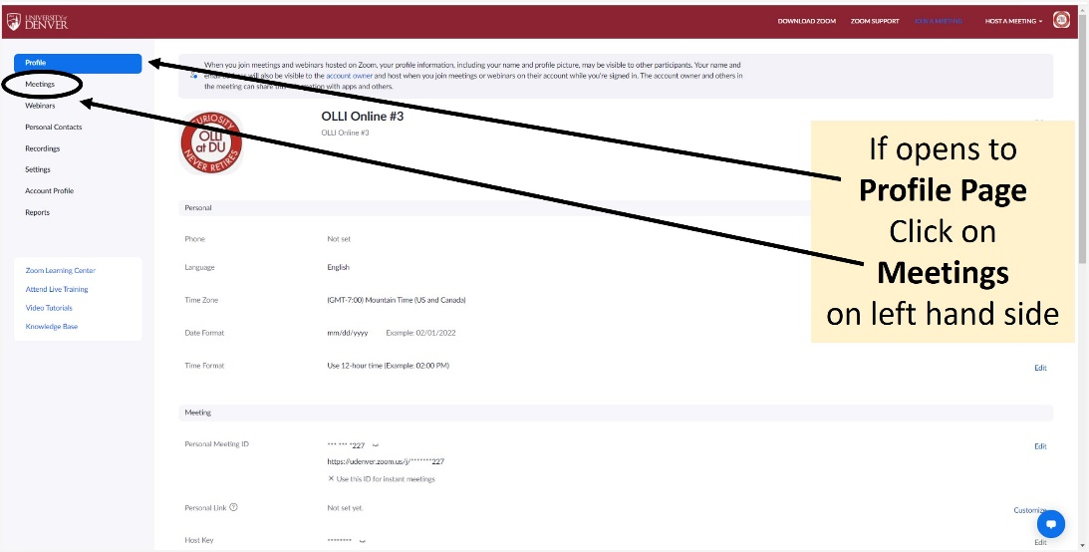
Meetings are organized by Day and Time
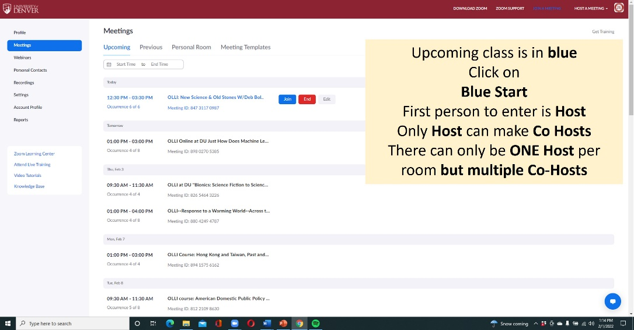
If you are the 1st Facilitator to arrive you are the Host.
NOTE: There can only be ONE Host and an unlimited number of Co-Hosts.
Only the Host can make others Co-Hosts.
When other facilitators arrive, admit them, and make the Co-Hosts. Co-Hosts can admit people from waiting room, visit breakout rooms, and share screens.
Who should be your Co-Hosts? Co-facilitators, Class Assistants, guest speaker(s) or participants that need to share screen or admit people into the Zoom room.
How to make someone a Co-Host:

