School Psychology Town Hall

Date/Time: October 8th, 2020 12:00-12:50pm
Facilitator: Jill Talley, SASP President
Note taker: Ainsley Echeverria, SASP Secretary
Participants: All Current School Psychology Students and Faculty

Important Information! Please READ:

- SASP portfolio page will have a cornucopia of resources! Check it out!
- Nominate Alumni for Alumni spotlight. To do so go to the SASP portfolio page!
- Have ideas for service opportunities?
  - Abby Hodges, SASP outreach coordinator would love your ideas for future outreach events. There will be one per month. Stay tuned for an announcement coming soon regarding the event for October! Please contact Abby.Hodges@du.edu with ideas and/or questions.
- If you have thoughts about the MA accreditation please voice your opinions here: https://apps.apa.org/accredcomment/
  - You can leave a comment under each section of the document
- CSSP Registration is NOW open
  - Members register here: https://www.cssponline.org/Member-Event-Registration
  - Nonmembers register here: https://www.cssponline.org/event-3627886
  - Want to become a member? Click here: https://www.cssponline.org/join
- Would you like to get involved in SASP but don’t have a ton of time?
  - Join an action committee! For each event an email will be sent out to gain volunteers to help plan and execute an event.
  - Join as many or as few events as you please!

Interested in Research? Check out these opportunities:
Vertical Research teams currently accepting students
Dr. Hazel’s VRT:
- Goal/scope: support systemic changes that promote equity; this includes allyship, student voice and adult listening, a positive youth development approach to multi-tiered system of supports (PYD-MTSS), and consultation
- Sample of Current Projects: systemic literature review of using art therapeutically with children; development of an allyship curriculum for educators
- Status of Projects: we are currently engaging in the systematic review—and need researchers!; the allyship curriculum development is in the initial phase
- How to join the team: email Dr. Hazel about your interests
Dr. Talapatra’s VRT
- Goals/scope: (1) increase access and minimize barriers for individuals with intellectual and developmental (IDD) in educational, vocational, and social setting; and (2) enhance the training of school psychologist so they are active participants in services for youth with IDD
- Sample of Current Projects: Systematic Literature Review of Transition Services; transition schools case study; syllabus analysis looking at how graduate schools train students to work with individuals with intellectual disabilities; content analysis of sexual health curricula for students with intellectual disabilities; understanding reasons why individuals with intellectual disabilities are incarcerated
- Status of Projects: We are currently in the writing phase for most projects; data collection is on hold due to COVID-19
- How to join the team: email Dr. Talapatra about your interests and email Jill Talley to receive the zoom link for the next meeting.
Dr. Raines’ VRT
- Goals/scope: School-based Pathways to Juvenile Justice
- Sample of Current Projects: Law Enforcement interactions with youth (specifically youth of color)
- Status of Projects: School Resource Officer training experiences
- How to join the team: School psychology pipeline and cultivation of faculty of color

Paid Research Position:
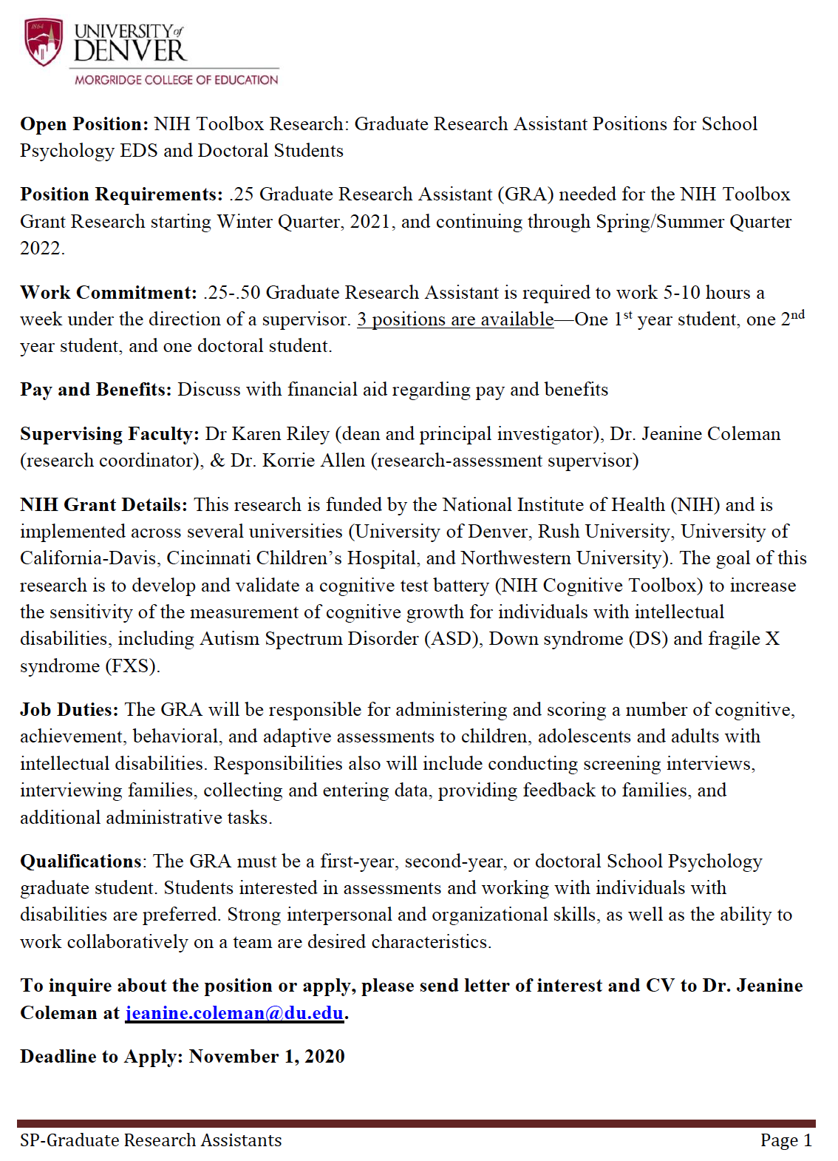

KUDOS!!
- Dr. Richards: Provided an honest/ challenging space to talk about implicit bias.
- Shout out to Dr. Coleman for making hyflex work in EC Development
- Congratulations to all of the PhD students who just got through comps!! & Shout out to Dr. Raines for being such an encouraging and inspiring mentor, advisor, faculty member, and director of training!! AND ALL students should give themselves a pat on the back for pushing themselves to be committed students and practitioners during a really challenging time!
- Eileen Cullen is rocking her first solo clinic case!
- Giant thank you to Dr. Talapatra for supporting SASP and answering all the board’s questions!
- Thank you to Dr. Hazel for her Thursday talks! The international day of listening was a wonderful listen!
- Awesome work to Elly Maras and Nicole Perez for getting all mentors and mentee matched AND for hosting a wonderful Back to School Event!
- Thank you everyone who participated in the Second Wind Walk with us on Saturday!
- Thank you Dr. Miller for all the support you have given the practicum 2 students as they navigate schools this year
- Incredible work Dr. Allen for organizing summer clinic to help PhD students get more experience and for getting the clinic up and running for the 2nd year cohort while keeping students safe!!
- Massive thank you to Dr. McDiarmid for working tirelessly to continually find placements for 1st year students.
- Fabulous job to Audrey Ford for getting wonderful speakers for the equity series
- Well done Abby Hodges for organizing the first outreach event!
- Great job Chase Burkhart for voicing student concerns in the faculty meeting!
- Wonderful work to our advanced practicum book club! It is so great to hear everyone’s thoughts!
- Shout out to the 1st year cohort for making graduate school work while attending some courses online and some in-person
- Thank you to the diversity course guides! I appreciate your guidance as we navigate our diverse world.
- The 1st years cohort is so engaged and handing the hyflex courses well!
- Good luck to everyone applying for internship next year!
- Interns, good work adapting to new school structures!
- Thank you to all the Faculty for creating engaging online/hyflex courses!
- Kudos to everyone for everything!

Minutes
I (Jill Talley) forgot to do the land acknowledgement. At MCE it is a policy to always start with the land acknowledgement. I apologize and promise to reflect on my actions.
I would like to start our minutes with the formal acknowledgement of the lands on which we convene.

The University of Denver resides on land held in stewardship by the Cheyenne andArapaho tribes. Throughout time, over 100 different tribal nations have a history of occupying the lands now defined as the State of Colorado. We recognize that the University of Denver (DU) resides on lands that are held in stewardship by various Indigenous communities. We recognize the descendant communities of the Northern Cheyenne Tribe of Montana, the Northern Arapaho Tribe of Wyoming, and the Southern Cheyenne and Arapaho Tribes of Oklahoma who were forcibly removed from this land. The University of Denver founder, John Evans, was culpable in the events leading up to the Sand Creek Massacre. We also acknowledge the Southern Ute Tribe and the Ute Mountain Ute Tribe, which are the only two federally recognized tribes in Colorado. ​

Today, Denver is home to many different citizens of Indigenous nations and we recognize their enduring presence on this land by paying respects to their elders, both past and present. ​

Please take a moment to consider the legacies of violence, displacement, migration, and resettlement that bring us together today and please join us in uncovering such truths at all public events. It is because of the sacrifices and hardships of the traditional Indigenous inhabitants of this land that we are able to be here to learn, collaborate, and share knowledge.

More about why we do the land acknowledgment and DU’s recognition and reconciliation of their involvement in the Sand Creek Massacre, Please Review the John Evan’s report at: https://portfolio.du.edu/evcomm/page/45570

Jill
- Welcome everybody!
- Townhall good place for voicing questions/concerns or sharing kudos
- All about open communication
Audrey
- New Equity page on the Portfolio page, includes scholarly articles
- Lecture series w/various guest speakers, should have invites in email already, please join!
- Climate survey – sending summary of results soon, looking for volunteers to taking over for next year, good way to take temperature of program as a whole and find out ways to improve
Nick
- CSSP Conference this Fall, Nov. 12th & 13th all virtual, registration closes Nov. 5th
- No networking breakfast scheduled at this time for upcoming interns, but stay tuned for other opportunities
- Members can get tickets here - https://www.cssponline.org/Member-Event-Registration
- Non-members here - https://www.cssponline.org/event-3627886
- Raffle for 1 free ticket, must be member, closes Oct. 13th- https://docs.google.com/forms/d/e/1FAIpQLScGH0HJvRM-unbrJCdkSGfcqs0KZSKUkVawV1fYCPncYlyGUQ/viewform?usp=sf_link
- Here is the link to become a CSSP member: https://www.cssponline.org/join
Lauren
- NSPW (formerly known as SPAW) Nov. 9-15th (week 9)
- T-shirt design contest, wear and take Zoom picture to share!
- More info to be sent out soon
- Advocacy is the big focus – encouraged to speak to undergrad classes, if interested email
Ashley
- Newsletter, new for the program, student run, quarterly
- See email for more details and GoogleForm below
  - https://forms.gle/Dx6Ws1dXu2x8bxE19
  - Looking for volunteers to be on the editorial board (at least 4 people)
- Build connections across cohorts, share passions/work, get inspired
- Spotlight – students/faculty/alumni
- Include local, national, and program-specific issues
- Email Ashley for more info/questions, Ashley.hudson@du.edu
Faculty
- PhD transition from EdS
  - Think carefully about own research interests, need to have a faculty research match (Drs. Hazel, Raines, and Talapatra accepting), 5-6yr commitment so very important, if no overlap, reach out to faculty to collaborate on next steps (e.g., recommendation letters)
  - At end of 1st yr eligible to confer MA degree, no guarantee of PhD at DU though, also keep in mind Winter application deadlines (start process now)
  - Pathways vs Licensure PhD, coursework and criteria different, accreditation different
  - For support, students who did this already:
    - Audrey.ford@du.edu
    - ellie.bold@du.edu
    - ashley.hudson@du.edu
- MA accommodation
  - NASP not in support due to lack of supervision and lack of preparation/training for practice
  - SASP form letter being sent out (NASP also has language), if you want to speak out against this, let’s advocate for EdS!
    - https://apps.apa.org/accredcomment/default.aspx
    - If sending letter (posting comment) to APA, do so by tomorrow (10/9) at midnight
  - APA not recognizing EdS degree as entry level, MA Health Service Provider degree broad not specific to School Psychology, scope of work/experience limited could harm children/schools, integrity of field at risk
- Networking event for students applying for internship, likely 2nd week of Dec., will be virtual, reps from various districts nearby and some not so nearby who will likely be review internship applications, more info to come
- Great job students working on Clinic and Assessment I!
Research team opportunities
- See section in agenda with more info
- Keep an eye out for announcements for openings (CRSHE, Pele, Marsico)
  - Talk to Abby Hodges or Elly Maras (elly.maras@du.edu) for questions about their experiences at these locations
Action Item
- Nominate Alumni for Alumni spotlight. To do so go to the SASP portfolio page!
- If interested in Newsletter Board, please apply by next week
Questions
- GRA positions for work study folks? See Financial Aid site or MCE email for more info - https://www.du.edu/admission-aid/financial-aid; MCE.finaid@du.edu

