Behind “Connecting the Pieces: Dialogues on the Amache Archaeology Collection”
Bonnie Clark, Department of Anthropology, University of Denver, Fall 2013

Connecting the Pieces: Dialogues on the Amache Archaeology Collection
During World War II Colorado’s tenth largest city was Amache, a one-mile square incarceration facility surrounded by barbed wire, guard towers, and the scrub of the High Plains. During the three years of its operation, over 10,000 Americans of Japanese ancestry lived there, yet their experience is muted in our national discourse. This exhibit is designed to encourage dialogue about this history anchored by fragments of those uprooted lives. The discussion begins with the community members and University of Denver students who curated this exhibit.
Why an Archaeology of Amache?
Conducting archaeology at a site occupied from 1942 to 1945 seems counterintuitive. Reams of government documents survive, announcing to those of Japanese ancestry that they had to leave their homes along the West Coast of the U.S. Photographs depict families as they hurriedly gathered only what they could carry - desperate to sell, destroy, or store the rest in the one week they had to prepare. Most importantly, people, including some of our exhibit contributors, remember their expulsion and confinement, first in the assembly centers, then in the War Relocation Authority incarceration facilities, like Amache.
Yet even with this rich documentary and oral record, archaeology reveals the rhythms of daily life in the camps-games played to pass the time or forget, gardens planted to beautify the stark military landscape, networks employed to improve living conditions. These objects provide a different way to encounter this experience, a physical connection to an unthinkable American episode.
Community member and student curators chose the objects in this exhibit because of the history they reveal and the stories they help us tell. They met to talk about their object, this history, and the message they hoped to share with visitors like you. Each of our curators—students and community members alike—have their own interpretation, expressed in their own voice. We encourage you to join the conversation. What do these objects say to you?
Thus began the Connecting the Pieces exhibit, curated in the Spring of 2012 at the University of Denver Museum of Anthropology (DUMA) gallery. It featured the contributions of twelve different teams consisting of one undergraduate student and one or two community members. Some teams chose multiple objects for their displays, most only one. Each object was accompanied by two interpretive labels – one written by the student and the other written by a community member. In between the texts were portraits of the team with their object, linking the people with their narratives (Figure 1).
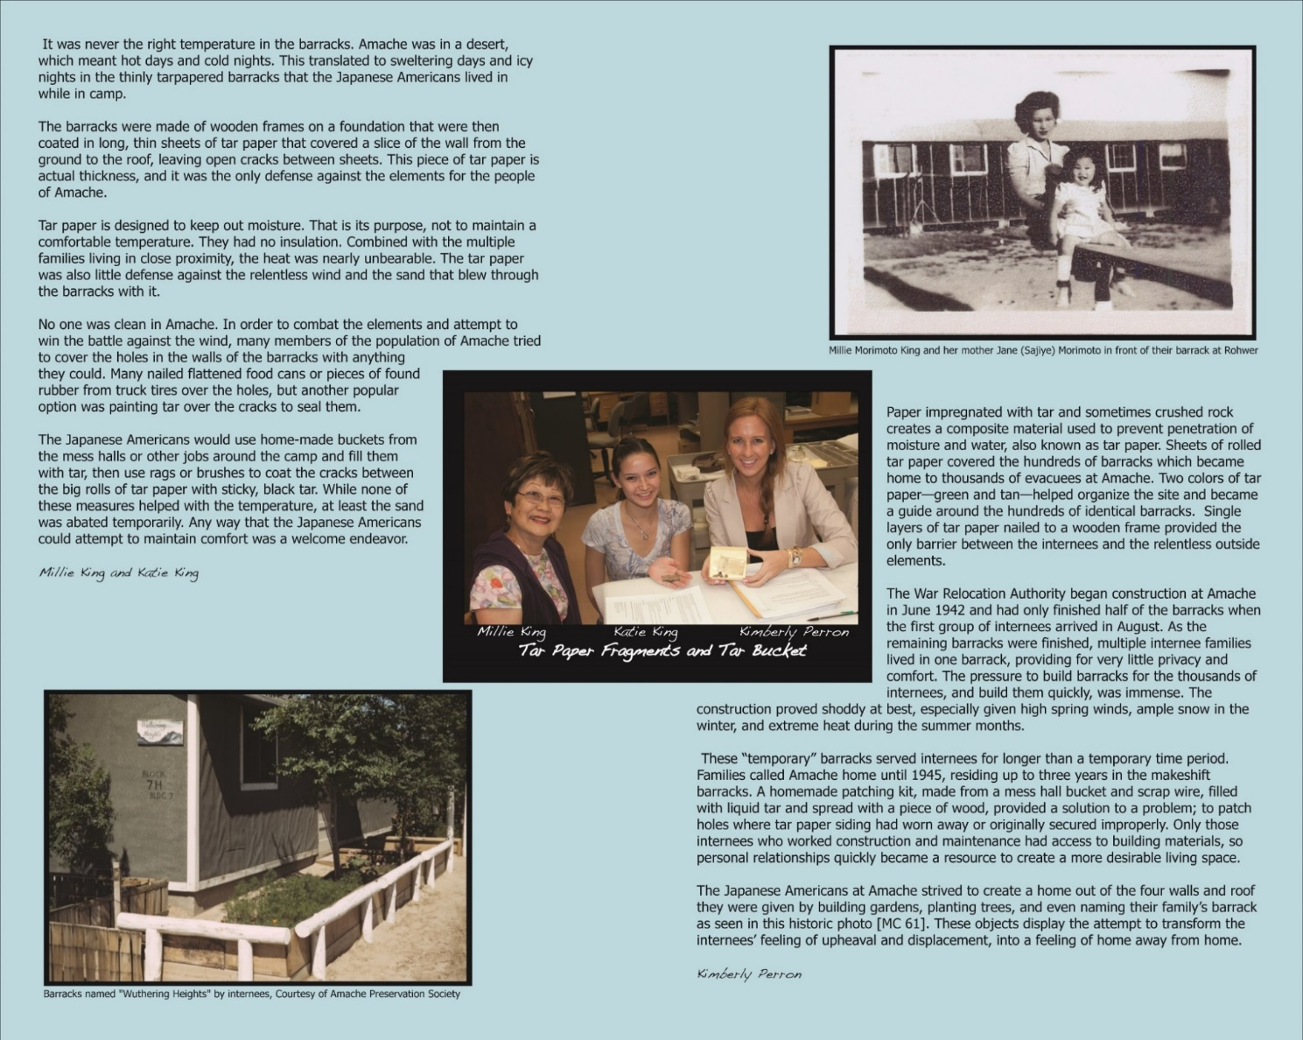
Figure 1: Example label from Connecting the Pieces

On the rear wall of the exhibit was “Join the Conversation,” designed as an interactive element of the exhibit. There were pens and sticky notes for visitors to respond to different prompts. One portion repeated the question with which the exhibit began, “What do these objects say to you?” under which were pictures of each object with space for sticky notes. The other portion began with a quote from one of our community curators May Murakami, who graduated from high school at Amache. “My hope is that people will better understand what went on during World War II.” This area featured broader questions about the significance of internment and the history of World War II:
“What does it mean to be American?”
“Where was your family during World War II?”
“What did you learn?”

Some Background
The planning and implementation of the exhibit were shaped by two different, yet complementary movements in the academy and the discipline of anthropology. The first is the push toward public engagement in higher education. Supported by conferences, journals, and institutional structures like the University of Denver’s Center for Community Engagement and Service Learning (CCESL), this movement is anchored in a commitment by individuals and institutions to apply academic research to real world needs. This commitment to research in the service of “public good” has a natural pedagogic application, in service learning. Courses with a service learning component promise students a chance to see the results of their academic labors bear fruit in the real world. If poorly conceived or a single intervention, service learning can be shallow or primarily self-serving (e.g. the greater good goes to the academy and not the community supposedly served). However, if part of a longer term relationship, especially one underwritten by the application of scholarship to the issue at hand, service learning enriches both the student experience and the relationships to community.
A second body of research and practice that informs this exhibit comes from the discipline of anthropology, and the resurgence of public or applied work. Indeed, Allison Wylie, a philosopher of science, suggests community engaged archaeology is a new paradigm of practice, one with significant ramifications for the future of the field (2008). A similar philosophical change is taking place in museum anthropology, where focus has shifted from objects to people, from exhibits to relationships. The Connecting the Pieces exhibit reflects the insights in particular of Museums as Places for Intercultural Dialogue (www.mapforid.it), an initiative undertaken by a consortium of European museums (Bodo, Gibbs, and Sani 2009). Two MAPFORID projects specifically informed the DU exhibit project. In “Choose the Piece” groups who were not traditional museum goers (immigrants to Modena, Italy) were invited to “adopt” one of 30 archaeological objects. They were encouraged to connect the history of the object to their own biography and at the conclusion of the project were given certificates of adoption. “Tongue to Tongue” a project of the University of Turin museum similarly involved community members who chose an object from the collections and developed an interpretation, but it was in dialogue with the more official voice of the museum curators, who also contributed to the exhibit (Bodo, Gibbs, and Sani 2009).
Connecting the Pieces was conceptualized (and partially funded) as one element of the larger DU Amache Project, a community-engaged research project. The centerpiece of the project is a field school in historical archaeology and museum studies held every other summer at the site Amache and the Amache museum (near Granada, Colorado). Although the engaged element has evolved over time, a key element is the chance for DU and students from other institutions to work with members of three key stakeholder groups: former Amache internees, people who had family at Amache, and residents of the Town of Granada. Witnessing the impact of what Stephen Silliman (2008) has called “collaborating at the trowel’s edge” on field school students and community members encouraged me to seek additional venues to deepen engagement. Although an often underutilized resource, museum galleries are another avenue for collaboration using archaeological materials.
The goals of Connecting the Pieces ran the gamut from quotidian to ambitious. First, the exhibit was timed to occur during Archaeology and Historic Preservation month. That timing allowed it to be promoted statewide by the foremost institution devoted to the history of the state, History Colorado., Additionally, the exhibit opened immediately after the yearly pilgrimage to Amache. The exhibit was promoted at the pilgrimage and timed so that participants who came from out of town might be able to attend the exhibit. Finally, the exhibit took place prior to and during the Summer 2012 DU Amache field school. Visitors to the exhibit were invited to join the team at the site during the four weeks of research, in particular our open house day.
The more ambitious goals were primarily geared to the process of creating the exhibit. The first was to make connections between students and those with a stake in this history. We anticipated this would likely involve bringing together our students with individuals different from them, likely in age and in personal connection to internment history. This was in part driven by feedback from a project I did with students in the 2009 version of “American Material Culture.” Those students participated in a community open house, serving as docents for an object from Amache. Feedback from students indicated that although they were inspired by the engagement, some felt they knew less about these items than many of their visitors, a position that was uncomfortable. For the 2012 students would be teamed with people who had personal expertise, thus they could focus on what their growing skills in object and research interpretation could provide. Additionally we hoped that working together on the exhibit would create a space for dialogue across the personal differences of the team members. This dialogue, it was hoped, would touch not just on the facts of this history, but also its larger implications including its impact on the Japanese American community, the fragility of civil liberties, and what it means to be “American.” Because the resulting exhibit would be open to the public, it was hoped that visitors would learn more about internment history and perhaps even be moved to contribute through the exhibit interactive.

The Process
Recruitment for the exhibit began at an early 2012 event cosponsored by the DU Amache project and the local chapter of the Japanese American Citizens League. The event was devoted to the history of internment and seemed a good chance to connect to potential community partners. Several of the more evocative Amache objects were placed on a table with the sign, “Adopt an Amache Object.” Additionally, I personally recruited people met at presentations about Amache. Finally, several volunteers were recruited through postings to the Japanese American organizations and religious congregations. The majority of volunteers were Japanese American, although a few were Caucasians with their own personal connections to internment or just a general enthusiasm for the topic. Only two of the community partners had been themselves interned at Amache. Even more had been interned at other camps, while a few were the descendants of internees.
The student participants came from the Advanced Seminar course, “American Material Culture.” They engaged in the project as a service learning component for the course. The course is geared to teaching students how to research and interpret tangible history. Researching and producing the exhibit label for their Amache object is just one of their projects for the course. (See Exhibit A for a description of the project as included in the course syllabus).
Rather than arbitrarily deciding exhibit pairs, we tried to let mutual interest make the connections. That way the team members would have a common interest from which they could build their collaboration. Community volunteers and students alike chose three objects they would like to work with. Although in the end some of the students were assigned an object because of community member interest, most teams were based on those shared preferences.
Team meetings took place several weeks into the term to allow students time to build some expertise in object analysis. Students were prepared through course content devoted to internment history, the research of the DU Amache project, exhibit label writing, and service learning. The first real engagement with their chosen objects took place at the first team meetings. Teams were encouraged to handle their object, looking closely at it (Figure 2). They were also provided with information regarding where and how it was recovered from Amache and the results of the analysis of the object done by students enrolled in a previous course in Historical Archaeology. The teams were given some questions to help guide their conversation (see Exhibit B).

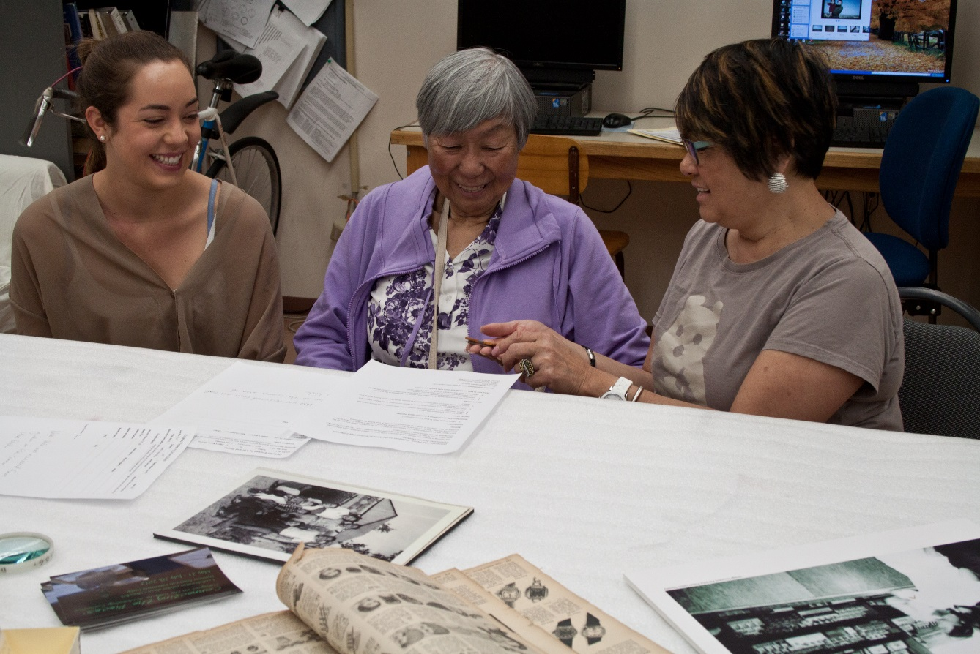
Figure 2: Exhibit team meeting with DU student, former Amache internee, and her niece
Ironically, those teams whose community members had less personal experience of internment were more likely to be guided by those questions. Students teamed with former internees (whether from Amache or the other camps) found that much of their time was spent in listening to their partner’s personal histories and memories. Those stories were often only tangentially associated with the object at hand. Their reflective journal entries about this meeting suggest that they understood this departure from their agenda to serve a higher purpose. Not only did it make this history present and real for the student, it gave their partners a chance to discuss a history so often silenced.
Following that meeting, students had a full class period to do additional research on their object, often including specific questions that came from the meeting with their community partner. Each student used an analysis grid that had them confront their object using the lenses of materials, construction, function, provenance (connections to places and people), and value. They were pushed to begin with the clues provided by the objects themselves, then related objects, then outside documentation (often photographs, but also other primary materials related to the site). They also consulted with DU Museum of Anthropology staff Brooke Rohde and Anne Amati about what their exhibit might look like (for example how should their object be displayed). Based on both their research and their meeting, they each created an approximately 300 word object label and identified graphics to be included in their exhibit (typically historic photographs).
The student labels and the community member labels were turned in at approximately the same time. Student labels were edited for content and style, as well as their coherence with community member labels. Students were provided detailed feedback which shaped their final label content. Community member labels were generally only lightly edited. Any content changes on community partner labels were sent to them for approval. Using these labels and the objects themselves, the overall exhibit design was created by two DU graduate students whose upcoming thesis work involves community collaboration in museums. These students have been active consultants throughout the process, beginning with community partner recruitment.

Results
Connecting the Pieces either met or exceed our expectations on many fronts. Data from reflective student journals suggests that many of the civic education goals of the project did come to fruition. One student wrote that her work on the exhibit humanized this history. “It wasn’t just dates and words anymore, but actual objects that families used.” Another student echoed this sentiment. Working with her partner, a woman who lived as a child at the Heart Mountain internment camp, made what had previously seemed “ancient history” come alive.
Some of the meetings were more difficult, including a student whose partner was a toddler when her family was interned in Arkansas. The community partner had no personal memories of her time in camp because she was so young. When asked by the student what she had learned about the experience from her family, the partner became silent. She then shared with the student that her parents, like so many who experienced internment, refused to talk about it. Although this was uncomfortable, it was a very powerful teaching moment. The student involved wrote about how this exchange made it clear to her just how difficult this history remains for many whose lives were forever changed by it. She wrote of the exhibit, “It is a channel for some to grieve, share, celebrate, remember and honor the past. No matter what stage of recognition each person is at, the exhibit provides a way to acknowledge all of these feelings and try to understand them.”
As is often the case with service learning, the students also felt inspired to produce quality work. One student wrote, “There is a very different feeling between having finished a test or a paper than having finished an exhibit, which can be observed by many people to help pass on education and understanding.” Another wrote that she was inspired by the challenging project. “It was not just about analyzing and interpreting the significance of artifacts, but about using our knowledge of objects to give back to the community.” In that same vein another student wrote, “I think the most rewarding part of this project was knowing that we paid homage to people who lived through Amache or any other Japanese internment camp.”
A substantive critique of service learning is that students often gain much more from the experience than do community members. Although that might be true of Connecting the Pieces, there are a number of indications the exhibit was a positive experience for them too. One of the community curators brought her granddaughter into the exhibit design process. She wrote in the exhibit guestbook, “This was a wonderful experience…The exhibit is amazing, personal, and enlightening.” Another wrote, “This is a great exhibit. Glad to be part of the effort to make positive something borne out of tragedy.” The exhibit opening was well attended, with over 75 people taking part, including a number of the student and community partners. At the open house one community curator thanked me for the opportunity to contribute to the exhibit. As he pointedly said, “No one ever asked me before.”
Feedback in the guestbook indicated that the exhibit also impacted public knowledge of this history. As one visitor wrote, “Taking people to understand the reality of WWII and not simply getting them lost in what the history books say about victory is a task that we should undertake. You have done it wonderfully. Thank you.” Likewise, visitors participated in the interactive elements, adding their voices to those of the co-curators. One of the student favorites was this note put up next to a photograph of one of the objects in the exhibit, “This makes me celebrate with joy for the sake of the owner who says with his bow tie, ‘I am not a prisoner of politics because I am my own person whom the barbed wire cannot contain.’”
Originally our intent was to just display the exhibit only in our own gallery. However, following the opening, we received a request from a neighboring university to host Connecting the Pieces as a travelling exhibit. This took some revamping, but DUMA staff and students were able to transform it into a travelling exhibit. Later a second request came from the archives at another university to host it in their library. The exhibit will travel at least one more time, to a regional public library.

References Cited:

Bodo, Simona, Kirsten Gibbs, and Margherita Sani (editors)
2009 Museums as Places for Intercultural Dialogue: Selected Practices from Europe, MAP for ID Partners, Dublin.

Silliman, Stephen W. (editor)
2008 Collaborating at the Trowel's Edge: Teaching and Learning in Indigenous Archaeology. University of Arizona Press, Tucson.

Wylie, Alison
2008 Legacies of Collaboration: Transformative Criticism in Archaeology: The Archaeology Division Distinguished Lecture. In American Anthropological Association, San Francisco.

Exhibit A: Excerpt from syllabus for ASEM 2449, American Material Culture, Spring 2012

Exhibit Project: You will work in teams with community members to create an exhibit using objects derived from archaeological research at Colorado’s Japanese American internment camp, Amache. This project will provide a number of experiences to students: 1)You will engage in dialogue with your community partners about object research, about objects of internment, and about how (and why) to present this information to the public; 2) This project gives you a chance to synthesize data in a polished and succinct way guided by editorial feedback; and 3) You can use your newly acquired skills (in object research and exhibit writing) to draw attention to an element of US history that is often misunderstood or avoided. You will reflect on this experience in your service learning journal.

Exhibit B: Agenda for student / community partner meeting:

Connecting the Pieces: Dialogues on the Amache Archaeology Collection Community Partner Meeting
This meeting is designed to introduce the partners in the Amache Object exhibit to each other and to their object. This is also an opportunity to strategize about your exhibit labels. We will also be taking a photograph of each exhibit team and their object.
Each object will be accompanied by two labels, one written by the DU student partner and one by the community partner. The labels should be approximately 300 or less words in length.
Agenda:
Introductions –
- What do you hope to gain from this project?
Read object information sheet & Examine object together
Discuss object
- What interests you about this object?
- What important stories about Japanese American life, internment, or US history might this object help tell?
- Does either partner have a personal interest or family connection to this object, internment camps, or World War II history?
- What additional research might you each want to pursue about this object before writing your labels?
Discuss exhibit
- Are there any physical features of this object that should be highlighted in the exhibit?
- What basic information should exhibit visitors be told about this object? (For example should visitors know where in Amache the object came from?)
- What is the likely key message of each partner’s exhibit label?

