Protocols for OLLI Online Class Sessions
Note: Each Course has a Zoom Room Host (ZRH), Facilitator(s) (CF); Class Assistant (CA) and Zoom Tech Squad (ZTS) if possible
Zoom Room Host sends invitation inviting members to each course
Invitations have embedded passwords; registration requirements; and is repeating for the duration of the course.
Note – we have had experience with the registration email going into spam and/or if the individual entered a different email into the registration system it not being obvious. Instructions for all members will indicate such.
Invitations are set with Waiting Rooms for members and facilitators to join through
ZRH settings do not allow for sharing of screens beyond those identified as hosts and co-hosts
ZRH Opens Zoom Classroom 30 Minutes before the class begins
45 minutes before on the first week
ZRH begins clicking members into the classroom
When the Class Assistant arrives, that individual is made a co-host
When the Zoom Tech Squad member arrives, that individual is made a co-host
When the Facilitator(s) arrive, the facilitator is made a Host when they are ready. (co-host if the ZRH does not intend to leave the class)
If the facilitator is made Host, they then make the ZRH a co-host
The second facilitator is made a co-host
During the open time the ZTS and CA assist members with any Zoom issues
If the issue is specific to the computer, the ZTS assists as much as possible and then directs the individual to the Zoom.us site for further assistance
If non-members enter, CA’s, ZTS and ZRH can ‘bump’ them with a simple click of a button and they are not allowed back into the room. Class lists are used to determine who is an authorized member.
If a member drops due to their computer system, they will reenter the waiting room and can be allowed back to the class via the CA, ZTS or ZRH (as all are co-hosts)
10 minutes before the class begins, the CA and/or ZTS walk all members through the screen settings we are asking each member to set on their own computers. These settings allow for the best viewing and the least interruption with ‘I can’t see’ statements
Classes begin on time with the Facilitator launching the class.
At this point (or before as we become more comfortable with the process) the ZRH leaves the meeting. They will need to be let back in via the waiting room before the class is ended.
The CA and/or ZTS will have the participant ‘side bar’ open during the class to allow members back into the class.
At the end of class, the ZRH will return (if they left the class), be allowed back into the class and made the ‘Host’ for the class so the Facilitators, CA’s and ZTS can leave and others can stay for up to ½ hour for community engagement.
Facilitator: If you are preparing to leave the class and when you click on end meeting the following screen shows:
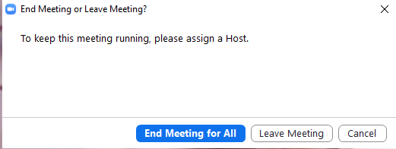
You need to go back and make the ZRH the Host for the class or you will end the class for all participants.
The ZRH will send reminder email with the link for the specific class at the beginning of each week with the link of the recurring meeting for the week.

